Fuzzy Complex Assessment of Activities of the Agent in Multi-Agent System
N.Yu. Mutovkina^{[0000-0003-0137-4189]}
Tver State Technical University, Tver, Russia
letter-boxNM@yandex.ru
Abstract. In article the technique of an fuzzy complex assessment of the agent in multi-agent system from a line item of efficiency of his activities is considered. It is set that overall performance of the agent depends on three principal components: level of professional competence of the agent, his personal qualities and emotional background. In a technique the approach integrating both expert estimates, and the actual data about results of operation of the agent in system is applied. The system of the indices which are best characterizing separate aspects of activity of the agent in multi-agent system is offered. At the same time the key characteristic is the level of his professional competence. The fuzzy complex assessment of activities of the agent in system gives the chance to reveal more and less effective agents that is important for further acceptance of administrative decisions.
Keywords: Multi-agent system, intelligent agent, efficiency of activities, linguistic variable, fuzzy logic, expert estimates.
- Introduction
Currently, multi-agent systems (MAS) and distributed artificial intelligence have become an integral part of people's lives and continues to actively develop in various fields of human activity, for example [1], [2], [3], [4], [5]. The basic principle of the design and implementation of a MAS is that every agent in such a system has only some knowledge and understanding of the task at hand. He can solve only a limited part of the global problem. Therefore, the number of agents in the MAS depends on the complexity of the task. It is very important to develop mechanisms of interaction of agents, which could contribute to the achievement of the overall objective, and not “taken away” from it. Every agent in the MAC gets the role, the complexity of which should not exceed its capabilities [6]. The distribution of tasks between agents in the system can be carried out by one of two principles:
- “the rigid principle”: the common goal (a global problem) is divided into private goals, subsystems come to light and specific jobs are issued, and then the found solutions are aggregated. At the same time control is executed by uniform “Centre”;
- “the soft principle”: assignment of roles and distribution of tasks happen during interaction between agents and, in general, are random. While such MAS there are resonant, synergistic effects.
No matter what principle applied when building MAS, include such components as: a set of the intellectual entities called by agents; the environment, having all necessary conditions for operation of agents; set of tasks (roles, functions); a set of certain correlations between agents that is provided with creation of different organization structures (configurations); a set of actions of the agents emerging in model their behavior [7].
To assess the performance of each agent is very difficultly. The activity of the agent is described by many indicators, that have not only quantitative, but also descriptive expression. For making managerial decisions it is necessary to have the aggregated assessment, which would include a minimum number of indicators, but at the same time would provide a full characterization of the evaluated object. The transition from the initial set of private indicators to the aggregate indicators is called an integrated estimation procedure. Input, output indicators and procedure of aggregation are called a system of integrated assessment [8].
This research is a part of a bigger research, which is developing a creation of models and methods of decision making in modern complex control systems in terms of vague uncertainty.
- Theoretical Aspects of a Research
In the study of mechanisms for complex estimation two tasks are solved:
- the aggregation of information, that adequately reflects the substance of the interaction of agents (solution of problem multi-criteria optimization);
- the study of a manipulability of mechanisms of complex estimation which are mechanisms with reporting of information and the problem of manipulation appears in case of reporting of information in MAS [9].
In addition, as a source of information for estimation of activity of the agents, along with statistical data are the opinions of the experts, it appears the problem of manipulation in mechanisms of expertise. However, this problem is successfully solved in [10], so in this article on this question the author doesn't stop.
Getting a complex assessment of activities of the agent in MAS entail the following difficulties:
- to build the analytical model MAS is not possible because of essential complexity, lack of experimental data for statistical modeling and unpredictability of agents behavior;
- source of information are not only quantitative but also qualitative data. It uses not only statistical data but also the opinions of experts. The values of such input data cannot be set unambiguously;
- qualitative assessment is not only charactered for certain input parameters, but also for the resulting criterion, which is the efficiency of activity of the agent in the system.
Solution to the problem is the transition from analytical or statistical models to Fuzzy models that can be built either on the basis of expert knowledge or based on observed data [11].
The activity of the agent in the MAS is determined by its behavior, which is based on two components-the rational and emotional [12]. The rational component ($W$) is that the agent has a need to apply existing knowledge, skills and he understands that from his behavior in the system depends his the success and further development. That is, the rational component is the unification of the competence ($Y_{P}$) of the agent and the level of development his positive personal qualities ($Y_{r}$).The emotional component ($Ψ$) describes the inner world of the agent and consists of its personal characteristics. Emotional background of an agent depends on: the working environment and of agents with which to interact; the information incoming to agent; the resources security of the agent and his self-assessment. On information, providing to the agent, often is superimposed interference, called “noise”. Noises can be generated by accident or intentionally, but in either case they make it difficult, and sometimes completely exclude a proper understanding of the information. This leads to errors in the agent activity, which are negatively affect on his emotional state. The self-esteem of the agent is expressed by the degree of satisfaction with the results of his own activities, that is, how the agent is satisfied with how he copes with own responsibilities according to the assigned role in the MAS.
Analysis of rational and emotional component is allowed to build a hierarchical structure of criteria of estimation of activity of the agents in the system. This structure is shown in table 1. Evaluation criteria are characterized by the importance and degree of severity. Not all criteria are of equal importance, it all depends on the initial conditions of the functioning of the MAS. The use of equal weights when summing assessments can lead to loss of information. The importance of the criteria can be defined either by using the method of analysis of hierarchies (Analytic hierarchy process – AHP) [13], or under rule Fishburne [14].
In brief, the AHP is as follows. At each level of the hierarchy is formed of paired comparisons matrices which have the appearance of back of symmetric matrices. To find the vector of priorities at corresponding the matrix of paired comparisons, it is necessary to determine the main own vector, which corresponds to the greatest own value of matrix. The elements of the vector of priorities will be calculated as the relationship of the elements of the eigenvector to the sum of its elements. Pairwise comparison matrix is forming for the criteria at all levels of the hierarchy. The elements of the vector of priorities of the criteria, which are comparing, are calculating. Then hierarchical synthesis is performed. With the help of this procedure the vector of priorities of criteria on lower level is established, which are well measurable.
The second approach to determining the significance of criteria consists in organizing them in descending order of significance (1) and application of rule of Fishburn (2):
$y_{1}≥y_{2}≥\text{.}\text{.}\text{.}≥y_{i}≥\text{.}\text{.}\text{.}≥y_{N}$, (1)
$y_{i}=\frac{2⋅\left(N−i+1\right)}{\left(N+1\right)⋅N}$, (2)
where $y_{i}$ − the level of significance criteria i;
$i$ − the sequence number of criterion;
$N$ − a number of criteria.
Fishburne's rule indicates, that about levels significance of criteria only the relation (1) known. Then estimate (2) corresponds to the maximum value of entropy of available information uncertainty about the assessment criteria. If all criteria have the same importance, it is a fair formula:
$y_{i}=1/N$. (3)
The importance of the criteria in the table 1 is defined by the formula (2).
Table 1. Priorities of criteria in two-level hierarchical model
Criteria of the first level of hierarchy | Priorities of criteria of the first level | Criteria of the second level of hierarchy | Priorities of criteria of the second level
Competence level | 0,50 | Reliability | 0,50
Competence level | 0,50 | Potential | 0,33
Competence level | 0,50 | Self-sufficiency | 0,17
Personal qualities | 0,33 | Skill to communicate | 0,50
Personal qualities | 0,33 | Truthfulness | 0,33
Personal qualities | 0,33 | Absence of conflict | 0,17
Emotional status | 0,17 | Assessment by the agent of level of the resource security | 0,50
Emotional status | 0,17 | Agent's self-assessment | 0,5
To assess the severity of criteria of second hierarchy level, are applying fuzzy logic and fuzzy sets theory. The evaluation criteria are presenting in the form of linguistic variables with the corresponding term-sets. The transition from the clear meaning of a variable to a fuzzy meaning is carried out through the process of fazzification. Fuzzification consists in transfer the measured accurate value in value membership function of the appropriate term of a linguistic variable. To build the membership functions of terms, has been used the posterior approach. Membership functions constitute a piecewise-linear functions, in particular, the trapezoid function [1]:
$μ\left(x;a,b,c,d\right)=\begin{aligned}\left\{0, x<a, | \right.\left\{\frac{x−a}{b−a}, a≤x<b, | \right.\left\{\text{1, }b≤x≤c, | \right.\left\{\frac{d−x}{d−c}, c<x≤d, | \right.\end{aligned}$, (4)
where $\left[a,d\right]$ − carrier of an fuzzy set;
$\left[b,c\right]$ − kernel of an fuzzy set (optimistic assessment of variable values) [1].
The accurate meaning is translating in the group of fuzzy numbers, which correspond to the membership functions of different terms of the linguistic variable. Thus, the criteria of the second level of model (table 1) is presenting as a merger of the membership functions of the relevant terms:
$y_{\text{ij}}=\frac{μ_{\text{ij}}^{1}}{T_{1}}⊕\frac{μ_{\text{ij}}^{2}}{T_{2}}⊕\text{.}\text{.}\text{.}⊕\frac{μ_{\text{ij}}^{k}}{T_{k}}$, (5)
where $y_{\text{ij}}$ − meaning of criterion i of level j of hierarchy;
$k$ − number of a term.
Using the fuzzy relation $Y_{i}×T$, the fuzzy composite matrix $M\left(Y_{i}\right)$ is built, lines of which represent meanings of membership functions of the appropriate terms for components of the bottom level of hierarchy.
Integrated assessment of the agent activities in MAS is obtained in two stages:
- getting fuzzy evaluation of criteria for the first level in the hierarchy as a result of the multiplication of the vector of meanings of the weights of the criteria of the second level of hierarchy of criterion on the matrix of meanings of membership functions of this criterion ;
- getting fuzzy evaluation of a key criterion, which is the agent's effectiveness in MAS, on the same principle as in point 1). This assessment is expressed as the vector, the quantity of elements in which is equal to number of the entered terms.
The procedure of a defuzzification is carried out for obtaining accurate meaning and can be realized by different methods. The most frequently used Centroid method, according to which the centers of mass of the relevant terms are calculated according to the formula (6) [15]:
$\text{CG}\left(T\right)=\frac{\int_{\text{min}}^{\text{max}}{z⋅μ\left(z\right)\text{dz}}}{\int_{\text{min}}^{\text{max}}{μ\left(z\right)\text{dz}}}$, (6)
where min and max values are the left and right points of an interval of the carrier of an output variable.
The physical analogue of Centroid method consists in finding the center of gravity of the flat figure, which is limited to the axes of coordinates and the schedule of the membership function of fuzzy set. The formula (6) is applied to the continuous sets. If the discrete fuzzy set is considered, then its defuzzification by a method of the Center of Gravity is executed on a formula:
$\text{CG}\left(T\right)=\frac{\sum_{l=1}^{q}{z_{l}⋅μ\left(z_{l}\right)}}{\sum_{l=1}^{q}{μ\left(z_{l}\right)}}$. (7)
A clear evaluation of the effectiveness of the agent in the MAC is calculated by the formula:
$E=\frac{\sum_{i=1}^{n}{\text{CG}\left(T_{i}\right)⋅Z_{i}}}{\sum_{i=1}^{n}{Z_{i}}}$, (8)
where $n$ − number of terms;
$Z_{i}$ − an element i of an fuzzy assessment of efficiency of activities of the agent in MAS.
- Practical Implementation
From all variety of criteria of effectiveness of agent in MAS, based on the results of the expert analysis, the following were selected: $Y_{P}$ − level of competence of the agent, which is characterized by such criteria as: $y_{1}^{P}$ − reliability of the agent, $y_{2}^{P}$ − potential of the agent and$y_{3}^{P}$ − self-sufficiency of the agent; $Y_{r}$ − personal qualities of the agent, basic of which are: $y_{1}^{r}$ − skill to communicate, $y_{2}^{r}$ − truthfulness and $y_{3}^{r}$ − absence of conflict of the agent; $Ψ$ − an emotional component that includes: $ψ_{1}$ − assessment by the agent of level of own resource security and $ψ_{2}$ − level of satisfaction of the agent of results of own activities.
Reliability of the agent can be interpreted as the ratio of the number of tasks completed previously, to adopted tasks. Potential of the agent can be defined on the basis of execution of number of standard tasks for a unit of time. Self-sufficiency of the agent is equivalent his independence, i.e. a possibility of the agent to carry out certain tasks without involvement of other agents of MAS. Skill to communicate of the agent is the relation of number of its direct partner connections with other agents of system and the current number of agents in system. Truthfulness of the agent is interpreted as number of the messages proceeding from the agent which aren't containing “noise” in comparison with total number of the messages transferred by the agent to other participants of system. Absence of conflict of the agent is defined by quantity of conflict situations in which the agent participates (is their initiator) divided into total number of the conflicts in MAS for a certain time period.
After arrangement of priorities and calculation of coefficients of the significance of criteria for rule of Fishburn's (table 1) each of criteria of the bottom level of hierarchy was presented in the form of a linguistic variable, with corresponding a term set:
$T=\left(T_{1}−\text{ ital }low\text{,}T_{2}−\text{ ital }average\text{,}T_{3}−\text{ ital }high\right)$. (9)
All range of change of meanings of each criterion was partitioned into the levels, corresponding to terms of a linguistic variable (9), as shown in table 2.
Table 2. Weight factors of criteria and division of the ranges of change of meanings of criteria into levels
Criterion | Weight coefficient | Range of changes of values of criterion in selection |  | Low level |  | Average level |  | High level
$$y_{1}^{P}$$ | 0,5 | 0,1 | 1 | 0,1 | 0,4 | 0,5 | 0,8 | 0,9 | 1
$$y_{2}^{P}$$ | 0,33 | 1 | 50 | 1 | 10 | 11 | 35 | 36 | 50
$$y_{3}^{P}$$ | 0,17 | 0,1 | 1 | 0,1 | 0,3 | 0,4 | 0,7 | 0,8 | 1
$$y_{1}^{r}$$ | 0,5 | 0,01 | 0,2 | 0,01 | 0,07 | 0,08 | 0,13 | 0,14 | 0,2
$$y_{2}^{r}$$ | 0,33 | 1 | 15 | 1 | 7 | 8 | 11 | 12 | 15
$$y_{3}^{r}$$ | 0,17 | 0 | 1 | 0 | 0,2 | 0,3 | 0,5 | 0,6 | 1
$$ψ_{1}$$ | 0,5 | 15 | 100 | 15 | 40 | 41 | 75 | 76 | 100
$$ψ_{2}$$ | 0,5 | 1 | 10 | 1 | 3 | 4 | 7 | 8 | 10
Membership functions of terms are described by ratios (4) and are provided in figures 1 – 3.
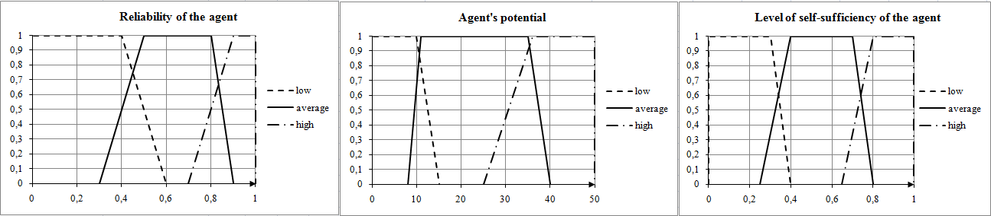
Fig. 1. Membership functions to criteria
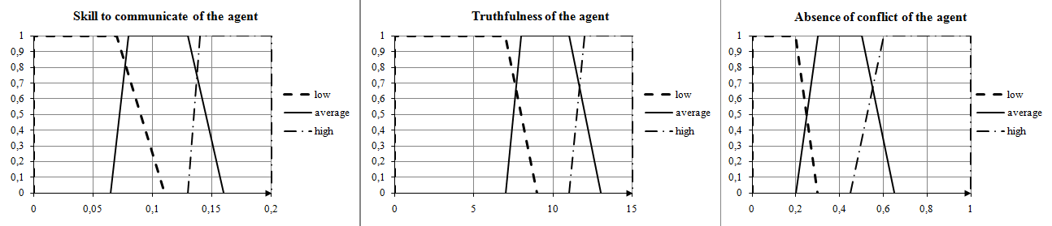
Fig. 2. Membership functions to criteria
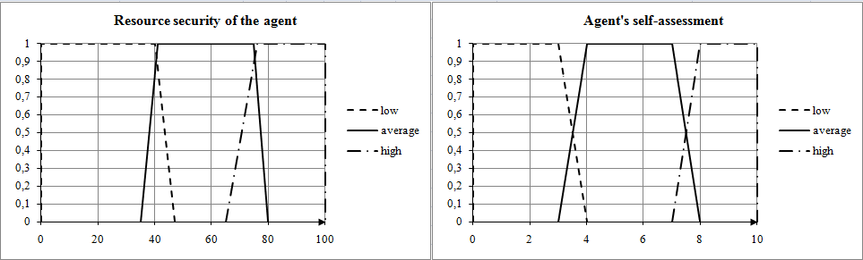
Fig. 3. Membership functions to criteria
The agent, whose efficiency of activities is estimated, possesses the following characteristics: $y_{1}^{P}=0,\text{85}$, $y_{2}^{P}=\text{37}$, $y_{3}^{P}=0,\text{34}$, $y_{1}^{r}=0,1$, $y_{2}^{r}=\text{12}$, $y_{3}^{r}=0,\text{53}$, $ψ_{1}=\text{83}$, $ψ_{2}=7,5$. According to the accepted rule of a fuzzification the following meanings of membership functions of the appropriate terms (table 3) were received.

Table 3. Meanings of membership functions
Criteria of the second level of hierarchy | Priorities of criteria of the second level | Meanings of membership functions of the appropriate terms
Criteria of the second level of hierarchy | Priorities of criteria of the second level | Т1 | Т2 | Т3
Reliability | 0,5 | 0 | 0,5 | 0,75
Potential | 0,33 | 0 | 0,6 | 1,00
Self-sufficiency | 0,17 | 0,60 | 0,6 | 0,00
Skill to communicate | 0,5 | 0,25 | 1,0 | 0,00
Truthfulness | 0,33 | 0 | 0,5 | 1,00
Absence of conflict | 0,17 | 0 | 0,8 | 0,53
Assessment by the agent of level of the resource security | 0,5 | 0 | 0,0 | 1,00
Agent's self-assessment | 0,5 | 0 | 0,5 | 0,50

The result of the first stage of obtaining the integral estimation is the matrix of the kind:
$M\left(Y\right)=\left[\begin{matrix}0\text{.}\text{102} & 0\text{.}\text{55} & 0\text{.}\text{705} \\ 0\text{.}\text{125} & 0\text{.}\text{801} & 0\text{.}\text{4201} \\ 0 & 0\text{.}\text{25} & 0\text{.}\text{75}\end{matrix}\right]$. (10)
At the second stage the vector was received, which representing an fuzzy assessment of efficiency of activities of the agent in MAS:
$\vec{Z}=\left[\begin{matrix}0\text{.}\text{0922} & 0\text{.}\text{5818} & 0\text{.}\text{6186}\end{matrix}\right]$. (11)
The output variable $E$ also has a term set (9) and is set by means of ratios (4). Her membership functions are provided in a figure 4.
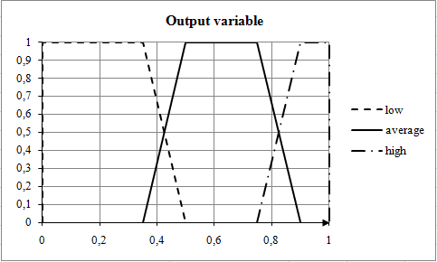
Fig. 4. Membership functions of an output variable
The centers of gravity of the appropriate terms were calculated by a formula (7): $\text{CG}\left(T_{\text{LL}}\right)=0,\text{21}$, $\text{CG}\left(T_{\text{AL}}\right)=0,\text{617}$, $\text{CG}\left(T_{\text{HL}}\right)=0,\text{943}$. The accurate value of an output variable, calculated on a formula (8), made 0,74. This assessment is interpreted as “average efficiency” of activities of the agent in MAS. Really, the considered agent has no sufficient independence in case of the decision of tasks. At the same time it has a medium level of sociability (established circle of relationships, the caring from new contacts) and of the conflict-free (new contacts, as a rule, are a source of conflict). Despite the sufficient level of resources the agent is not using its full potential.
- Conclusions
The article describes the techniques, developed by the author, for obtain a quantification of cumulative indicator of efficiency of activity of the agent in MAS. The technique is based on determination of the significance of criteria by which the assessment is carried out, and application of the theory of fuzzy sets, which well proved in case of the decision of difficult to formalize tasks.
The selected criteria are structured hierarchically. In this case complied with the condition, that the increase in a particular metric associated with the improvement of activities and condition of the agent. If for this index the opposite tendency is watched, then in the analysis it should be replaced with the conjugate. The most important criterion of the first level in the analysis is the level of competence of the agent.
On the basis of the carried-out estimation of activities of agents in MAS conclusions about overall performance of system in general are drawn and the instructions for increase in efficiency having advisory nature are worked out. In case of detection of absolutely ineffective agents, they are removed from the system.
- Acknowledgments
Work is performed with assistance of the Russian Federal Property Fund, the project No. 15-01-05545 A.

References
- Mohammed Mekidiche, Mostefa Belmokaddem, “Application of Weighted Additive Fuzzy Goal Programming Approach to Quality Control System Design”, IJISA, vol. 4, no. 11, pp. 14 – 23, 2012. DOI: 10.5815/ijisa.2012.11.02.
- Haiying Ren, Siwei Li, “A Heterogeneous Agent-based Asset Pricing Model and Simulation”, IJEM, vol. 2, no. 4, pp. 9 – 18, 2012. DOI: 10.5815/ijem.2012.04.02.
- E.V. Krishnamurthy, “Agent-based Models in Synthetic Biology: Tools for Simulation and Prospects”, IJISA, vol.4, no.2, pp. 58 − 65, 2012. DOI: 10.5815/ijisa.2012.02.07.
- Mohammed Abbas Kadhim, M. Afshar Alam, Harleen Kaur,"A Multi-intelligent Agent System for Automatic Construction of Rule-based Expert System", International Journal of Intelligent Systems and Applications(IJISA), Vol.8, No.9, pp.62-68, 2016. DOI: 10.5815/ijisa.2016.09.08
- Purba D. Kusuma, Azhari, Reza Pulungan,"Agent-Based Buyer-Trader Interaction Model of Traditional Markets", International Journal of Intelligent Systems and Applications(IJISA), Vol.8, No.11, pp.1-8, 2016. DOI: 10.5815/ijisa.2016.11.01
- Satyendra Singh Chouhan,Rajdeep Niyogi, “An Analysis of the Effect of Communication for Multi-agent Planning in a Grid World Domain”, IJISA, vol. 4, no. 5, pp. 8 – 15, 2012. DOI: 10.5815/ijisa.2012.05.02.
- M. Wooldridge, An Introduction to MultiAgent Systems, Chichester: John Wiley & Sons Ltd, 2002. ISBN 0-471-49691-x.
- Burkov, V.N. Theory of the active systems and enhancement of an economic mechanism / V.N. Burkov, V.V. Kondratyev, V.V. Tsyganov, A.M. Cherkashin. M.: Science, 1984. 272 p.
- Burkov, V.N. How to control the organizations / V.N. Burkov, D.A. Novikov. Moscow: “Sinteg”, 2003. 400 p.
- Mutovkina, N.Yu. Methods of the coordinated optimization of modernization of the industrial enterprises: the dissertation for a degree of Candidate of Technical Sciences; specialties 05.13.01, 05.13.10. – Tver: TvGTU, 2009. 219 p.
- Hodashinsky, I.A. Methods of soft estimation of values: monograph / I.A. Hodashinsky. Tomsk: Tomsk state university of management systems and electronics, 2007. 152 p.
- Mutovkina, N.Yu. Behavioral models of intellectual agents in the course of information exchange / N.Yu. Mutovkina, V.N. Kuznetsov, A.Yu. Klyushin // Management systems and information technologies. 2013. No. 1.1 (51), pp. 178 – 183.
- Saati, T. Decision-making. Method of the analysis of hierarchies / T. Saati. M.: Radio and communication, 1993. 278 p.
- Fishburn, P. The theory of usefulness for decision-making / P. Fishburn. M.: Science, 1978. 352 p.
- Mousumi Mitra, Atanu Das, “A Fuzzy Logic Approach to Assess Web Learner's Joint Skills”, IJMECS, vol. 7, no. 9, pp. 14 – 21, 2015. DOI: 10.5815/ijmecs.2015.09.02.

